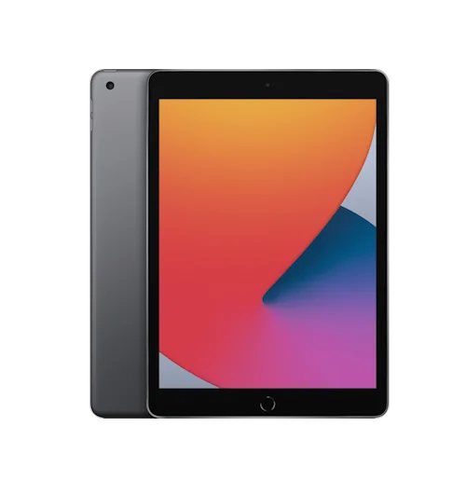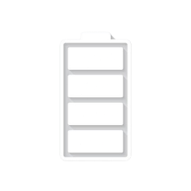

* Apple iPad 10.2
* Processor: Apple A13 Bionic (7 nm+)
* Front Camera: 12 MP
* Rear Camera: 8 MP
* Display: 10.2 “
* NFC: No
* Colors: Silver, Space Gray
* Operating System:
* iPadOS 15
* Charging Type: Lightning, USB 2.0
* SIM: Nano-SIM and eSIM
* Fingerprint: Yes
* Release Date: 2021, September 24

RAM

3

GB

ROM

256

GB

BATTERY

8557

mAh



+001-28272300-2466-2469



webmaster@cellinfo.com



A-65, ACME Co. ,

Street No. 12,

New York

Ask Me Ltd.